FRIENDLY FANTASY FOOTBALL
Introduction
Fantasy sports are played by 50.4mil Americans and is a $9.48bil market¹. While there are numerous unique ways to play, most of them are tailored for a high-information managers, setting lineups based on injuries, weather, defense, etc. For a newcomer to the sport, there’s a lack of options allowing a low-information manager to succeed in a standard league. A quick search on beginner advice will show many results about how to get into standard fantasy sports as a beginner, but there don’t appear to be options for a simpler version of fantasy. This report outlines a method to create a fantasy format that is more accessible to beginners, and can be used by families, less informed fans, and experts alike.
Not only will it be shown that this method is better for an average fan in terms of simplicity, this structure has other uses including the aforementioned season-long fantasy format, predicting real matchups for bettors, and informing fantasy managers about which teams are more prolific in fantasy football. Each of these topics will be explored in the remainder of the report as well as a Literature Review, Methods, Results, and wide-ranging Conclusions/Recommendations.
Literature Review
As this is a new structure, scoring teams based on a best-ball style standard ESPN points per reception (PPR) format using only their players for the lineups, there is unsurprisingly a lack of literature to review. After each week of the NFL season, NFL Fantasy releases a Perfect Lineup and Imperfect Lineup containing the highest and lowest fantasy points by specific combinations of players in a standard PPR format², but that is about as close as it gets. Week 3 of the 2023 NFL season saw the Miami Dolphins defeat the Denver Broncos 70-20 and a lineup of just Dolphins players would have scored 194.46 points and beat many teams in standard EPSN leagues. From there, the idea to create best ball-style fantasy teams for each NFL team each week and compare them to each other was born. This simpler version has only 32 teams to draft as opposed to the 654 standard eligible players last year, with options on how to draft and play the teams against each other in a season-long format.
This aligns well with information for beginners in general, with football being understood to be the easiest of the major sports to get into.

Methods
First task in this project was compiling the fantasy PPR scores, for which Stathead³ was used. The data was selected utilizing the “Player Game Stats Finder – Football” tool with the following criteria: “For single games, in 2023, in the regular season, sorted by descending Fantasy Points (PPR)”. The PPR column already has the score required for this report. 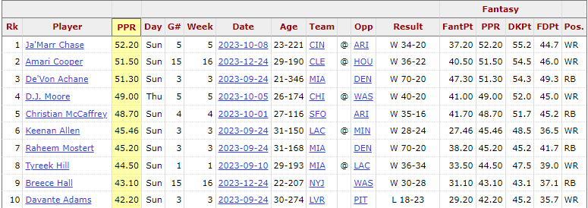
Table 1. Top 10 PPR Performances in 2023
From there, the data was loaded into a SQL database. Stathead currently does not have a “download all” option, instead there is “Export” > “Get table as CSV (for Excel)” or “Get as Excel Workbook”. Either way, only the 200 results visible per page are output, requiring a copy-paste for all 6480 resulting rows. Next, the data required some cleanup. Specifically, positions G (guard), LB (linebacker), OL (offensive line), DT (defensive tackle), C (center), DB (defensive back), P (punter), S (safety), and CB (cornerback) were removed. FB (fullback) was treated as RB (running back). The positions kept include QB (quarterback), WR (wide receiver), RB (running back), TE (tight end), K (kicker), and DST (defense/special teams). A spot check was completed by calculating player season averages and comparing to ESPN’s fantasy football site.
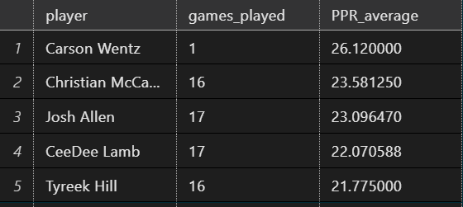
Table 2. Top 5 PPR Average for the 2023 season
The first step to creating team-based lineups is ranking the players based on partitioning by Week, Team, and Pos (position), and ordering by descending PPR. For a couple cases where there may be a tie, the first name alphabetically was used to not double count that tied PPR score. In the case of WR and RB, two of each player were required per standard ESPN lineup. Next up was selecting a Flex player, who is the highest rated WR, RB, or TE not already listed in the last step.
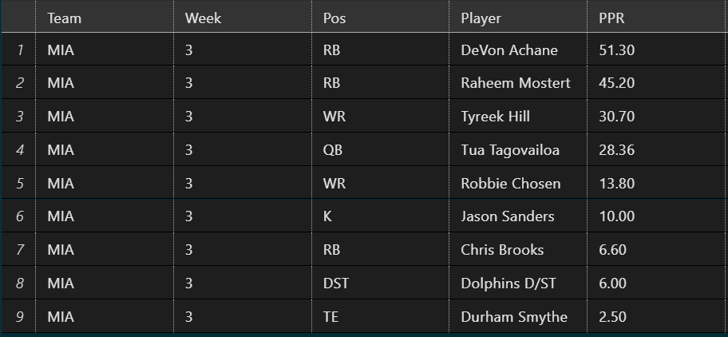
Table 3. FFF Lineup for Miami Week 3, total of 194.46 points
Now that the players have been selected, the sums are compiled by partitioning on Team and Week, to give a score for each team each time they take the field. Additionally, real life matchups can be used to compare fantasy results to real results, including whether they have the same outcome by using the beginning of the Result column from the Stathead pull:
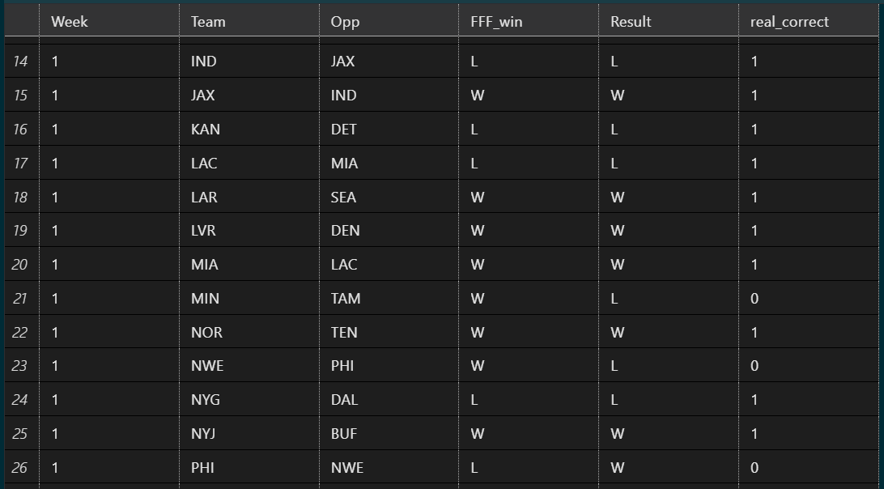
Table 4. Subset of Week 1 matchups, fantasy win, real win, and whether they match.
With the goal being fantasy team output in the form of a best-ball ESPN PPR lineup, the FFF Lineups have been created and the team sums compiled so the appropriate dataset has been created. To illustrate a beginner’s league outcome, each NFL team was assigned to one of four League Team (North, South, East, West) based on the division it plays in (e.g. Minnesota Vikings in the NFC North assigned to League Team North). Using the three teams within each League with the highest running average FFF score as their starting lineup (top three alphabetical in the first week), an all-play format matchup between the League Teams can be constructed. Essentially, this acts as a stand-in for a four team beginner’s league with no waiver or playoff and each team assigned to it’s division direction, as aa proof-of-concept for this league structure.
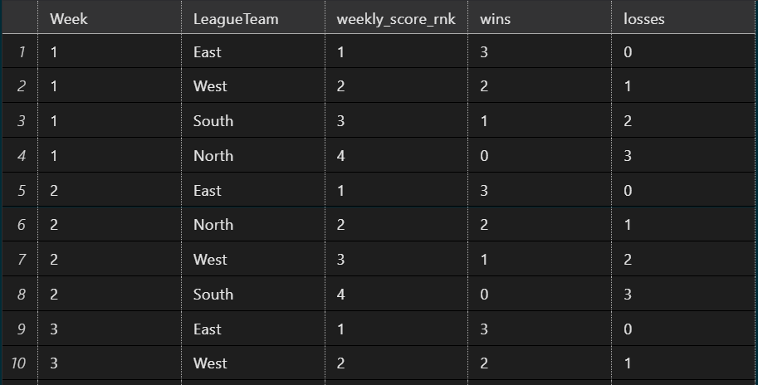
Table 5. First 10 results of League matchups

Results
Starting with the results of the League teams in the stand-in beginner league, team East won the most weeks, with 8 out of 18 weeks at first amongst the four, followed by 6 week wins by North, 2 by West and 2 by South.
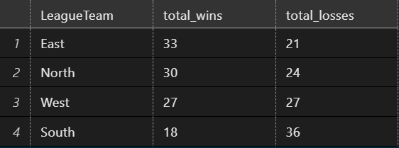
Table 6. Final wins/losses for League teams
This can be turned into a standard game to be played by the public by instituting a draft, waiver, and playoffs. A first iteration of this would include 4 or 8 teams, with 3 or 2 teams respectively to start per week. A bench would consist of 1-3 or 1-2 teams respectively with the remainder on the waiver wire. In terms of running this team, a manager would only need to follow 3-6 teams and start whichever has a better matchup or is playing better at the time. This is simpler to follow and analyze than a standard lineup of 17 players (9 starters, 7 bench, plus an IR slot), with fewer details to follow. As long as the team is not on a bye week, the team will play and score some amount of points, so only high-level detail like a major player injury or the opponent matters. It is incredibly unlikely a team would score 0 points, whereas a player in the starting lineup putting up a “doughnut” happens a handful of times per year. In standard leagues there are injuries, player matchups versus defense or individual cornerbacks, snap counts, depth charts, and other extraneous factors (grievance, paternity, etc.) to consider. Going a step further to make it easier, all teams could be drafted in the beginning of the season and “play” top 3 teams per manager each week in an additional best-ball level. This takes much more of a “sit back and watch” mentality as the manager learns the ins and outs of the league and start players.
For an expert or high-informed player, this format can still be enjoyed. With waiver wire tactics and all the aforementioned standard league elements, there is still enough complexity to interest the average fantasy sports player. What this structure does well is cater to beginners as their only league, but a fun added league for those already committed to leagues with their friends, coworkers, teammates, or online leagues. As the year goes on, powerhouse teams and those falling behind are identified and these high-informed players can leverage that knowledge to succeed and choose the best matchups while others fall behind.
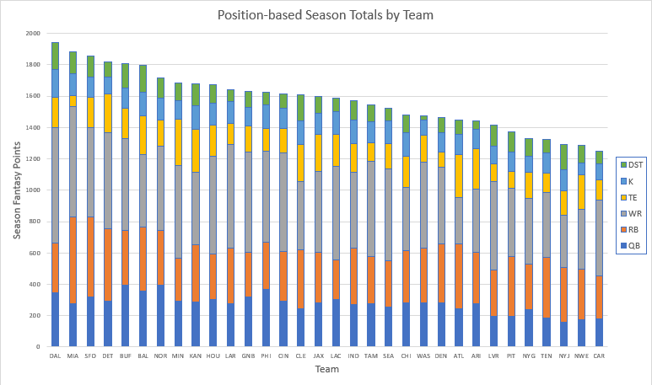
Figure 1. Season totals per team with all performances counted, colored by position
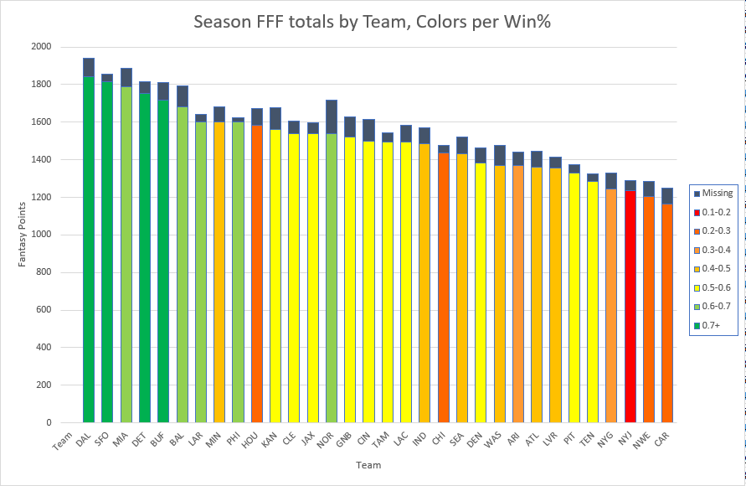
Figure 2. Season totals per team with FFF Lineup scores counted, uncounted values labeled Missing, colored by season win percentage.
From these two graphs, there are a few notable takeaways. First off in Figure 1, it would appear WR compiles the most points over the season, and that is true when checking a per-week per-team basis using the formula (total season sum / (18weeks * 32teams)):
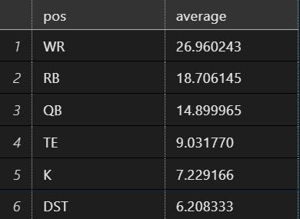
Table 7. Average score by FFF Lineup players scored for FFF teams each week
This seems to lend itself to the drafting strategy for players in typical leagues, where WRs will go off the board first along with RBs, then QB, TE, with K and DST kept for the last two picks, save for exceptional players who go earlier than their position would normally dictate. Pulling out individual positions, it can be seen which teams are stronger and produce more points at that position. For example, Dallas has a large WR segment, as they put much more emphasis on their passing game with CeeDee Lamb than their run game which struggled this year. Similarly QBs reside at the base of the stacks so they can be seen more clearly, including teams like Buffalo with Josh Allen and Philadelphia with Jalen Hurts. Interestingly the Saints stand out as one that wouldn’t be as obvious (Dallas with Prescott and a great receiving corps, Baltimore with Lamar Jackson). Turns out they put out a slightly above average 15.24PPR, with some impressive runs above the average, only pulled down by a handful of sub-9PPR weeks. This first figure also shows the total points output throughout the season, so it’s clear which teams put out more points overall compared to those that don’t do as well, signaling strong teams for managers to look for players to fill their roster.
From the second figure, we can see which teams closely align the FFF scoring with their record. Notable overachiever is New Orleans with a 0.647 win percentage (tied for 5th best), but recorded 14th in FFF lineup total score. An underachiever is Houston, who recorded a 0.235 win percentage (tied with 2 teams, only one lower) but recorded the 10th highest FFF score, being a highly productive fantasy team but unable to translate it to the real wins. Additionally, the Missing points for each team show how many “extra” points they scored that didn’t count towards their FFF lineup. This would be from a QB2+, WR3+, RB3+, TE2+ or potentially a second kicker on a team, any other player who does not qualify for the Flex position as the highest scorer of these lower players. When a team outputs a high number of points and has higher Missing points, this could be a spot to look for extra value for a player lower in the depth chart, and potentially a great handcuff to have on the roster as there is plenty of points in that team. For teams lower in production of FFF overall but a higher than average Missing, this would show a team whose production is too spread out and the players are all low producers, instead of the normal 3-4 high-value players on teams.
Another use of this metric is predicting outcomes of real life matchups for bettors. As of now the only ranking method is using a running average of the FFF score, comparing that to the upcoming opponent’s running average, with the higher team being predicted to win the matchup. This tracks as typically the more prolific team will be the winner as they are able to put up more points in fantasy, indicating a higher amount of catches, yards, and touchdowns than the opponent.
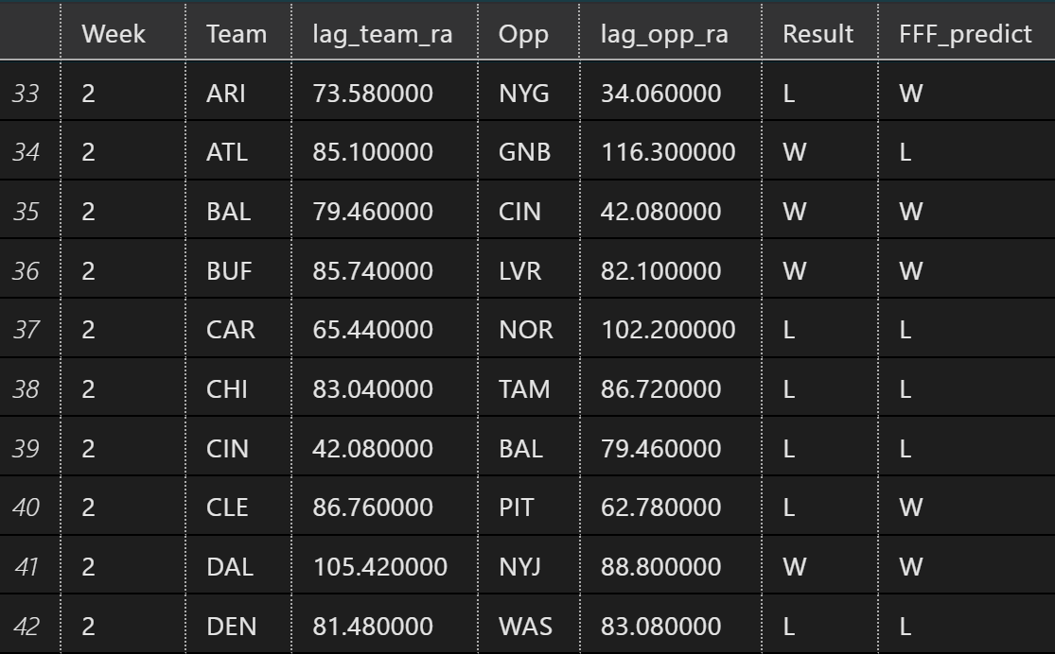
Table 8. Week 2 results vs running average prediction
After running over the whole season, the Team can be seen as a relevant predictor with teams ranging from 25% to 81% correct. Running a Pearson’s Chi-Square results in a rejection of the null hypothesis when utilizing the standard p <0.05 threshold ($X$² = 183.5, df = 31, p-value < 2.2e-16, critical value ~43.773), indicating the Team and FFF_predict variables are related. This is most likely due to teams that commonly underperform being predictable losers, and similarly common winners performing on both fantasy and real matchups. Conversely, the handful of teams that are middling can pull off a win or loss as easily as the other, leading to a less predictable outcome.
Instead running the Pearson’s Chi-Square on the Team variable predicting the real life result matching the fantasy result, the analysis fails to reject the null, therefore the team is not a predictor of the real life result matching the fantasy result ($X$² = 39.976, df = 31, p-value = 0.1296, critical value ~43.773).
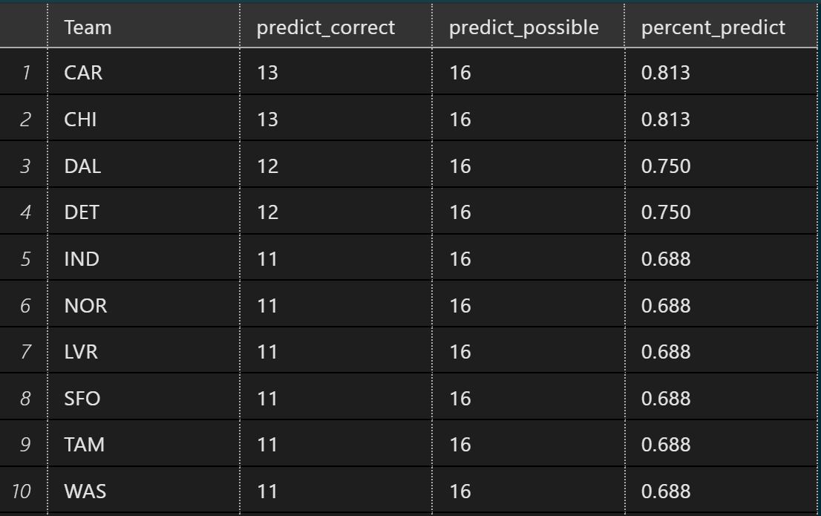
Table 9. Top 10 correctly predicted result for individual teams, excluding week 1 with no running average available
After running a Pearson’s Chi-Square where Week predicts the FFF matchup, the analysis is sufficient to reject the null hypothesis ($X$² = 44.472, df = 16, p-value = 0.0001671, critical value 26.30), indicating the Week is related to the FFF matchup prediction. Checking the Pearson’s Chi-Square for Week predicting the real life result matching the percent_predict, the analysis fails to reject the null, indicating the Week is not related to how well the FFF matchup predicts the real matchup (X-squared = 204, df = 192, p-value = 0.2631, critical value ~113.145).
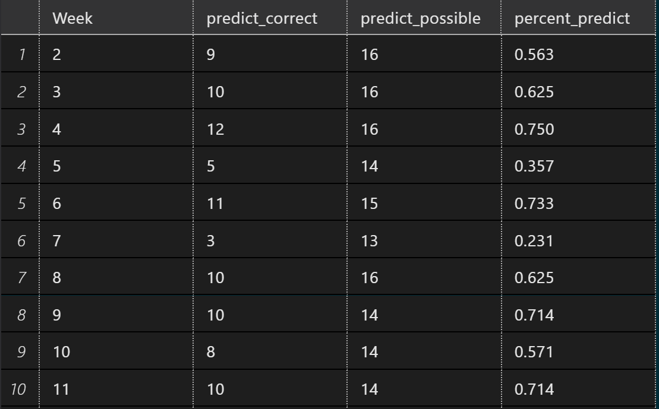
Table 10. First 10 week FFF predictions matching real result, excluding week 1 with no running average available
The average accuracy amongst the all matchups was 54.41%, meaning that the running average of FFF for a team matched up against an opponents aligned with the real life matchup result about 54% of the time. Medium⁴ reports the win percentage to profit over the long-term is 52.4%, and overall this method predicted slightly better than that over 2023, so this could be used as a betting tool to pick winners. The average difference between running FFF averages for 2023 was 15.1 points. When the difference was more than 15.1 points, the prediction was correct 60.6% of the time, and when less than 15.1 points it was correct 50.3% of the time. In other words, a higher than average difference in two teams’ running average bumps the prediction by 10%.
Conclusions / Recommendations
This fantasy format for beginners would be simple to produce for a company like ESPN, or to recreate for a home league using the methods detailed above, and it simplifies fantasy football for beginners to get a feel for the league before looking to play in a standard league. This would be great for kids, newcomers, and busier managers, or as a side league for those already playing in other fantasy leagues. This framing is also useful information for informed fantasy football managers to indicate team fantasy strength, and can assist in making decisions during a fantasy draft. Multiple aspects have previously been described for its use for high-information managers. Outside of the format and information gleaned for fantasy production, there is also the potential to use this as a betting tool. With simply a running average used, there was a ~54% chance of correctly predicting the real matchup. Also, looking for a correlation between margins of victory versus margins of FFF predictions to determine if a higher difference in running average is linked to a more “confident” prediction.
The most important future direction for this work is to include more information for predictions and FFF matchups. Notably, there is no data for any games prior to 2023, and the columns noted in Table 1 are all of the information currently included in the study. For example, different offensive/defensive schemes, coaching staff, weather, playoff implications, offensive snaps, etc. would be useful additions to the dataset. Also, working to create some ranking or value outside of the running average for predictions. For example, weighing recent fantasy performances as more relevant to the current play of the team, calculating averages for the available players in the team to estimate the FFF production, or instituting an ELO system⁵ to weigh wins against stronger teams as more valuable than those against weaker teams. It would be advised to boil down which players are the biggest contributors, perhaps per scheme/staff, so when a coach moves there is already an expectation for who will be the main producers along with expectations based on players’ past production. Additional analysis on the frequency for players counting in the lineup versus counting towards Missing when not injured would lend to determining their usefulness.
Another future direction would be linking this to ADP for players, or performance for teams based on where their players are drafted. For individual players, drafting too high and having them underperform greatly reduces playoff chances for a manager, whereas finding value late in the draft could be a golden ticket to the top. Furthermore, looking at player availability or other factors that change throughout the season could inform the prediction. Lastly, another future direction would be investigating Flex players and where the higher value typically resides, whether that is a specific team or position. This knowledge would be beneficial to have that common position left flexible and instead ensure the other positions are well covered.
References
¹Review of Fantasy Sports in the U.S.- Statistics & Facts. 2023. Statista.com. Statista Research Department. December 18, 2023. https://www.statista.com/topics/10895/fantasy-sports-in-the-us/#topicOverview.
²“Facebook.” n.d. Www.facebook.com. Accessed March 5, 2024. https://www.facebook.com/NFLFantasy.
³“Player Game Stats Finder - Football.” n.d. Stathead.com. Accessed March 6, 2024. https://stathead.com/football/player-game-finder.cgi?request=1&timeframe=seasons&year_min=2023&year_max=2023.
⁴Culver, John V. 2021. “Why 52.4% Is the Most Important Percentage in Sports Gambling.” The Intelligent Sports Wagerer. March 7, 2021. https://medium.com/the-intelligent-sports-wagerer/why-52-4-is-the-most-important-percentage-in-sports-gambling-16ade8003c04.
⁵DiSorbo, Matt. 2022. “Elo & You: How This Rating System Affects Fantasy Football.” Fantasy Footballers Podcast. May 25, 2022. https://www.thefantasyfootballers.com/articles/elo-you-how-this-rating-system-affects-fantasy-football/.

